Returning to Work Safely
While Adapting to the New Normal

Guidelines for (Business Name)
Re-Opening in a COVID-19 Environment

INTRODUCTION

THE CHALLENGE
Because of the COVID-19 pandemic and the restrictions necessary to reduce risk, workplaces will not be the same as we left them, and we will need to adjust. And while we all try to establish a new normal at our workplaces, there will certainly be an added layer of health and safety measures (physical distancing, screening, handwashing, etc.) required to ensure the safety of our employees (full time and contractual Rating Advisors), our operators and visitors to the office.
This booklet is designed to offer the guidance to help get business back up and running safely considering the pandemic.

WHAT IS THE NEW NORMAL?
Make no mistake: the impacts of the COVID-19 pandemic will change how we work. These changes extend to how individuals commute, enter workplaces, interact with others, manage tasks, and more. As our new normal is defined in a COVID-19 world, workplace health and safety and the importance of strong safety leadership are more critical than ever before. As an employer, you probably have many questions, such as: What are my responsibilities to employees as well as to operators who we interact with during inspections and visitors to the office? How can I ensure provincial requirements are being met? What does this new normal look like for the organization, office, employees, and operators? The first step is understanding the risk of COVID-19 exposure and transmission in your workplace. Jobs within a workplace vary, and so too will the risks of exposure. Performing an overall assessment of the workplace is important. Understanding the risks will help you determine appropriate precautionary measures.

The most effective way to prevent the spread of COVID-19 is to ensure employees and operators practice physical distancing. This requires maintaining at least two metres of separation between employees, operators, and visitors. It is encouraged to think outside of the traditional work environment and consider alternate working arrangements, such as conducting ratings remotely, and the use of virtual meetings rather than in-person.

Issuance of Public Health Emergency
Effective March 18, 2020, the Minister of Health and Community Services declared COVID-19 a public health emergency under the Public Health Protection and Promotion Act. While a public health emergency is in effect, the Chief Medical Officer of Health can introduce special measures that they believe are necessary to protect the health of the population.

COVID-19 OPERATIONAL PLAN FOR WORKPLACES
To ensure workplaces have documented their risk assessment and risk mitigation measures consistent with Public Health guidance and the Occupational Health and Safety Act and regulations, all employers must develop a written COVID-19 operational plan.

You must comply with the following provisions of the Mandatory Order:
- Employers of every workplace must take every reasonable step to ensure minimal interaction of people within two metres of each other, except in compliance with guidelines issued by WorkplaceNL and the Chief Medical Officer of Health. | - Employers of every workplace must take every reasonable step required to prevent persons who exhibit symptoms of COVID-19 from entering the workplace, in accordance with advice issued by the Chief Medical Officer of Health or WorkplaceNL. | - Employers of every workplace must take every reasonable step required to prevent persons from entering workplaces who have travelled outside Newfoundland and Labrador in the previous 14 days.

Just as viruses can mutate, guidelines related to COVID-19 can change. As an employer, you’re responsible for keeping up to date on current guidelines and to change your plans as required. Refer to the Provincial Government and WorkplaceNL websites for updates that may affect your workplace.

COVID-19 OPERATIONAL PLAN FOR WORKPLACES

Company Name: _____________________________________________________________________
Plan Owner: ________________________________________________________________________
Plan Implementation Date: ________________________
Plan Revision Date: _____________________________
Plan has been reviewed to assess any new risks or changes to regulatory guidelines (suggest monthly review):

Name Date Name Date

Name Date Name Date

Name Date Name Date

Effective Risk Mitigation – Infection and Prevention Controls

The best prevention controls in a workplace are achieved by first focusing on physical distancing and taking every reasonable step to restructure physical settings to increase space between people. Once you have exhausted all reasonable options in this category, move to the next stage within the inverse pyramid and conduct the same exercise, and so on until you reach PPE as a final step, if required.
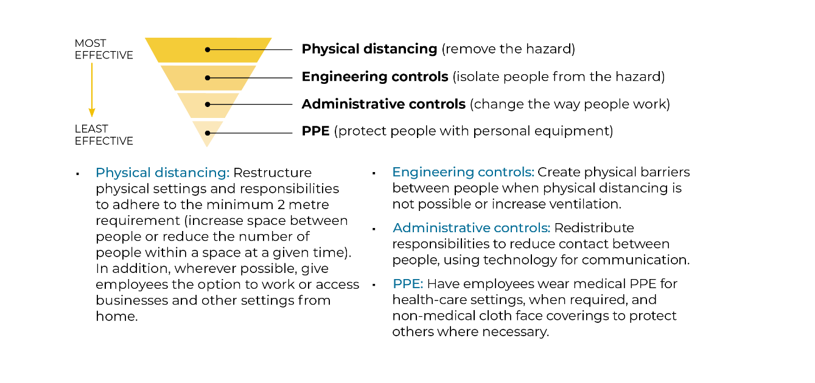

Action Items | Resources  (Examples, Templates, Guidance Documents) | Details of Implementation  (PPE Specifics, Frequency, Policy Name, Process, etc.) | How is it communicated?  (Poster, Training, Verbal Notice) | Status  (Done, In Progress, Not Started, N/A
Public Health Requirements (applies to EVERY workplace)
Risk Assessment | Risk Assessment Guideline Health Canada
Complete a risk assessment to determine the engineering, administrative controls and/or PPE controls necessary to mitigate the risk of COVID-19 exposure.
Know The Symptoms
Those who are infected with COVID-19 may have little to no symptoms. You may not know you have symptoms of COVID-19 because they are similar to a cold or flu. For symptoms refer to the Hotel Association of Canada Critical Response Plan.
Physical Distancing
Workplaces are exempt from the limitations on the number of people in gatherings; however, physical distancing of two metres (or two arm’s lengths) between individuals should be maintained as much as possible. Operations may need to be altered or postponed to maintain physical distancing. | https://www.gov.nl.ca/covid-19/files/Guidance-for-Workplaces.pdf
Increase the spatial separation between desks, workstations as well as individuals (e.g., employees, guests) from each other, by a 2 metre separation or use a physical barrier (e.g., cubicle, Plexiglas window.)
Move furniture used by guests in lobby and common areas so there is a 2 metre separation.
Handling of Monies and Supplies
Use of electronic payment devices are preferred when possible. However, if you must accept money as payment, ensure that employees are practicing effective hand hygiene after each instance by washing their hands with soap and water or using an alcohol-based hand sanitizer that contains at least 60 per cent alcohol. | https://www.gov.nl.ca/covid-19/files/Guidance-for-Workplaces.pdf
Do not touch your face after handling cash. Ensure that hand hygiene supplies are available for both patrons and staff at the point of purchase.
Limit the exchange of papers (e.g., signing contracts). If documents must be exchanged, leave them on a clean surface while maintaining a two-metre distance. Avoid sharing pens and office equipment. Disinfect after each use.
Supplies
Managers/owners must ensure employees have they have all the necessary supplies such as hot/cold potable running water, liquid soap, paper towel, and garbage bins, for handwashing; or a minimum 60 per cent alcohol-based hand sanitizer; cleaning and disinfecting supplies; and, personal protection equipment (non-medical masks and disposable gloves) if required. | https://www.gov.nl.ca/covid-19/files/Guidance-for-Workplaces.pdf

Action Items | Resources  (Examples, Templates, Guidance Documents) | Details of Implementation  (PPE Specifics, Frequency, Policy Name, Process, etc.) | How is it communicated?  (Poster, Training, Verbal Notice) |  | Status  (Done, In Progress, Not Started, N/A)
Public Health Requirements (applies to EVERY workplace)
It is important that a staff member be delegated responsibility to monitor supplies to ensure stock is maintained during operating hours. | https://www.gov.nl.ca/covid-19/files/Guidance-for-Workplaces.pdf
If you are a Food Establisment
Dining areas can operate at reduced capacity in accordance with the Guidance for Restaurants. Room service or take-out service options are encouraged. | https://www.gov.nl.ca/covid-19/information-sheets-for-businesses-and-workplaces/hotels-and-bed-and-breakfasts/
If room service is provided, use disposable plastic/paper cutlery and containers. For room service and take-out deliveries, leave all food and beverages at the guest’s door for pick-up by the guest.
For establishments with restaurants, please consult Restaurants Canada’s COVID-19 Rapid Recovery Guide | Restaurants Canada: COVID-19 Rapid Recovery Guide for NL - Reopening Resource for Foodservice Operators
Washrooms
Clean and disinfect frequently touched surfaces such as sinks, toilets, door handles, light switches. Keep soap dispensers filled in restrooms. Offer alcohol-based hand sanitizer that contains at least 60 per cent alcohol in areas where soap and water is not available. | https://www.gov.nl.ca/covid-19/information-sheets-for-businesses-and-workplaces/hotels-and-bed-and-breakfasts/
Handwashing Stations
Handwashing stations should enable handwashing by providing clean water, soap, paper towel, and a disposal bin. In the absence of this, minimum 60 per cent alcohol-based hand sanitizer should be made available.  Handwashing signs must be posted. | https://www.gov.nl.ca/covid-19/files/Guidance-for-Workplaces.pdf
Employees who handle cash or credit cards should practice proper hand hygiene. When hands are not visibly soiled and between customer interactions, alcohol-based hand sanitizers that contain a minimum of 60 per cent alcohol can be used.
Employees should wash their hands with soap and water when hands are visibly soiled, before and after any breaks, at the beginning and end of their shift, and before preparing food.
Wash hands immediately after handling guest room hard keys and key cards. After each guest leaves, disinfect keys. | https://www.gov.nl.ca/covid-19/information-sheets-for-businesses-and-workplaces/hotels-and-bed-and-breakfasts/

Action Items | Resources  (Examples, Templates, Guidance Documents) | Details of Implementation  (PPE Specifics, Frequency, Policy Name, Process, etc.) | How is it communicated?  (Poster,T raining, Verbal Notice) | Status  (Done, In Progress, Not Started, N/A)
Public Health Requirements (applies to EVERY workplace)
Worker Heath/Preventative Measures
All workers must self-monitor for symptoms and stay home if they are sick. | https://www.gov.nl.ca/covid-19/files/Guidance-for-Workplaces.pdf
Employers should have plans in place for increased worker absences due to illness or self-isolation requirements
All businesses should have a workplace illness policy. If a policy does not currently exist or does not align with COVID-19 recommendations, the following should be included:
o Sick employees must stay home or be sent home from work.
o Sick employees must use the self-assessment tool for COVID-19 and follow the subsequent directions.
Practice proper hygiene:
o Regular and thorough handwashing;
o Avoid touching face; and,
o Cough or sneeze into your arm.
Guidance on Personal Protective Equipment (PPE) for Employers
Employers should refer to the Provincial Government’s document on Guidance on Personal Protective Equipment | https://www.gov.nl.ca/covid-19/files/Guidance-on-Personal-Protective-Equipment-PPE-for-Employers.pdf
Additional Protection
Use non-medical face coverings for employees, clients and visitors to minimize the risk of transmitting COVID-19.  Develop procedure for selection, use, decontamination (if applicable), storage, handling, limitations, inspection requirements, change-out requirements and employee training, if face coverings are used. | Health Canada information on  non-medical masks and face coverings
Cleaning and Disinfection
Refer to the Provincial Government’s fact sheet on environmental cleaning. | https://www.gov.nl.ca/covid-19/files/factsheet-covid-19-environmental-cleaning-NL.pdf
Transporting of Customers/Guests
Please refer to the Provincial Government’s Guidance for Travelling in Vehicles | https://www.gov.nl.ca/covid-19/travelling-in-vehicles/

Action Items | Resources  (Examples, Templates, Guidance Documents) |  | Details of Implementation  (PPE Specifics, Frequency, Policy Name, Process, etc.) | How is it communicated?  (Poster, Training, Verbal Notice) | Status  (Done, In Progress, Not Started, N/A)
Public Health Requirements (If you are an Accommodations provider)
Management Contact Information
Management shall complete the contact information form found on Page 3 of the Hotel Association of Canada Critical Response Guide.
What To Do If Employee is Suspected of Having COVID-19
If an employee is suspected of having COVID-19 employers should follow the general procedures as outlined in the Hotel Association of Canada’s Critical Response Guide
What To Do If Employee Tests Positive For COVID-19
If an employee tests positive for having COVID-19 employers should follow the general procedures as outlined in the Hotel Association of Canada’s Critical Response Guide
What To Do If A Guest Is Self-Isolating
Follow the general procedures as outlined in the Hotel Association of Canada Critical Response Guide
What to do if a Customer/Guest tests positive for COVID-19
Follow the general procedures as outlined in the Hotel Association of Canada Critical Response Guide

Source: Worksafe - NBCOVID-19 OPERATIONAL PLAN FOR WORKPLACES TEMPLATE (vers. 1 May 8, 2020)| 1

